
Membership no.

RCPS Spring Exhibition 2026 - Tuesday 21st – Saturday 25th April 2026
Artist Submission Form (please complete a separate form for each piece submitted)
First Name: |  | Surname:
Address:
Contact Number:
Email Address:
Category: | Painting / Print / Illustration / Graphics / Textiles / Photography / 3D /Other
Title of Works
Year of Completion:
Medium:
Price: (if for sale)
Brief biography &/or description of piece(s):
(max.100 words)
An opportunity to share information about your work; to be displayed alongside it.
Contact details you would like displayed:
Size(s) of piece(s):
Detail of specific display, hanging requirements or preferences:
Information, Terms and Conditions:
Artwork submission:
- You can submit up to three artworks.
- Please include/attach images of the work being displayed.
- Please make sure a label with artist’s name and phone number is firmly attached to back/bottom of artwork.
- By submitting your work, you are agreeing to the terms and conditions on the sheet attached.

Key dates:
- Deadline for submission forms: Friday 6th March 2026.
- If you have been successful, we will let you know by Saturday 21st March 2026
- Your work must be delivered to The Poly on one of the following days: Tuesday 14th – Saturday 18th April 10am - 4.30pm 2026.
- The exhibition will be hung on: Monday 20th April 2026.
- Open to the public from: Tuesday 21st April, 10am-5pm 2026.
- Private View: Tuesday 21st April 5pm – 7pm 2026.
- The exhibition will close on: Saturday 25th April at 3pm 2026.
- Collection of artworks: Saturday 25th 3pm – 5pm or between Tuesday 28th – Saturday 2nd May. 10am – 4.30pm 2026.

Eligibility & Cost
- Submissions are open to all, with a focus on new and emerging artists.
- The work must be original, completed in the last two years, and should not have been shown at The Poly before.
- The submission fee for artists selected is £35/ free to Poly members. Please visit Membership - The Poly at Falmouth for more information about membership (you can choose to join if your work is selected - you don’t need to be a member at the point of submitting (although the more local members we have, the brighter The Poly’s future!)
- Please send your application form and images in one of the following formats: Word Doc, PDF, Jpeg. We cannot open other formats. If you have a Mac, we cannot open ‘Pages’, please send as a PDF.

Display requirements/Hanging details.
- 2-D work must be ready to hang, strung and D-ringed. Please see image below for an example. Un-strung work will not be accepted.
- For 3-D work, a method of display must be specified. If any work is particularly large or has any special display requirements, this should be outlined in submission.

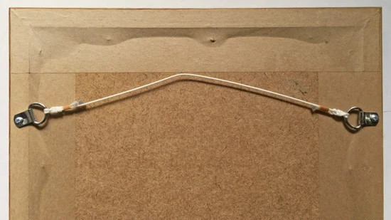

Use of Work
When selecting work, please remember that the exhibition is open to the public and artwork should be family friendly. The RCPS retains the right not to include any works that are unsuitable for this exhibition.
The RCPS may photograph and use images for promotional purposes.

Loss & Damage
The RCPS cannot be held responsible for any loss or damage to artwork.

Sales
If the work is for sale, its price must be set by the artist and indicated on the submission form.
20% commission + VAT on any work sold will be taken by the RCPS and will contribute to the upkeep of the building and the future of the society. Sold work cannot be removed until the end of the show, unless agreed by the artist.

Invigilating the exhibition
We would like to encourage artists to help with the invigilation of the exhibition. A timetable will be arranged closer to the event.

Data Privacy
The data given in this form will be held securely and only for the purposes of this exhibition. Once the exhibition has finished, your data supplied in this form will not be held on file or used for any other purpose.
You can read The Poly's privacy policy here: http://thepoly.org/contact/privacy-policy

Please email your completed form to: guild@thepoly.org or post to Sarah Edom or Jasmin Ford, The Poly, 24 Church Street, Falmouth, TR11 3E

