The Royal Cornwall Polytechnic Society Ltd (The Poly)

Trustee Recruitment Pack 2026

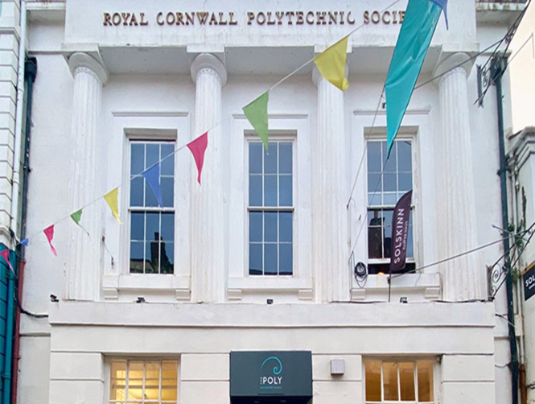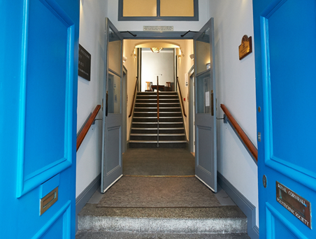

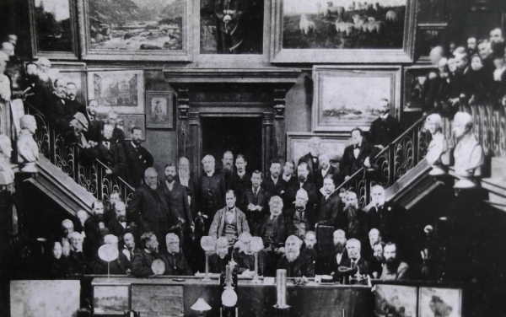

INTRODUCTION …………………………………………..2
ABOUT US…………………………………………………...2
VISION MISSION VALUES……………………………….4
GOVERNANCE AND BOARD OF TRUSTEES…………4
THE TRUSTEE ROLE: WHAT DOES IT INVOLVE?......5
HOW TO APPLY…………………………………………….6

INTRODUCTION

We’re delighted that you’re interested in becoming a Trustee of The Royal Cornwall Polytechnic Society (The Poly). We’d like to expand our Board with trustees who are enthusiastic about our work and can bring their experience to support our Director and staff team as we continue to develop our programme, diversify our audiences and upgrade our building so that it’s truly fit for purpose.
To provide effective governance, and to meet the needs of the organisation, it’s essential that a diverse range of skills and experience is represented on the Board. At the moment we have a vacancy for a trustee with professional experience or skills to lead on:
Environmental responsibility/ Sustainability/ Science

Your current commitments might mean that you’re unable to join right now? Don’t worry, if you’re interested, please get in touch for an informal conversation as it might take time for you to decide whether or not this is the right opportunity (our contact details are on page 6).

It’s important to us that our Trustees offer a wide range of perspectives, that they represent the diversity of the communities we serve. We’re committed to equality, diversity and inclusion and encourage applications from individuals across the spectrum of age, disability, socio-economic background, and racial identity. Whilst we hope that trustees will feel comfortable to bring their whole self to their work with us, we expect all members of our Board to consider inclusion in all aspects of what we do, and don’t expect individuals to represent specific groups or demographics.

ABOUT US

Founded in 1833, we’re a registered charity promoting engagement in the arts, sciences and Cornish history through film, live events, exhibitions, lectures, workshops. We also have a pottery on site and support local artists and makers through our Guild shop.
Based in an iconic Grade II* listed building on Falmouth’s high street – in the heart of the town – we’re the proud guardian of locally and nationally significant collections of heritage archives. We also own a collection of art works by Henry Scott Tuke (1858-1929), currently on long loan to Falmouth Art Gallery.
Environmental responsibility informs all our activities from investments, to procurement and programming. With no core funding we rely on income generated by our programme of activities, membership subscriptions, philanthropic donations and grants for special projects.
Our main challenge in recent years has been restoring our programme and income following pandemic closures, the protracted cost of living crisis and record levels of inflation. By the end of 2024, total admissions for the year were in excess of 23,740, for the first time exceeding pre-pandemic sales (22,782: 2019, 2,334: 2021). Since the pandemic membership subscriptions have also steadily increased from around 200 to over 700 in 2026. Despite these successes we remain on our long post-pandemic recovery and continue to plan for greater financial resilience and sustainability.
In April 2025 we took over the Café/bar as an inhouse operation, appointing three new members of staff. Transition has gone smoothly and after a slow start in its first year, the café/bar is now recognised as integral to our offer and successfully developing its potential.
As you’d expect, our building needs constant attention. A three-year phased programme of works to the Main Gallery was completed in summer 2023. Making the building accessible to all is a priority for the Board, and to this end we submitted an application to the National Lottery Heritage Fund in November 2025 to support our Sustainable Access project. This is a competitive process and although we submitted a good quality bid the outcome (in March 2026) was unsuccessful. We are currently in the process of taking advice from NLHF about other routes to funding and delivering this important capital development project.
In the 19th century, the Royal Cornwall Polytechnic Society (RCPS) played a pivotal role in the history of Falmouth (and Cornwall) through encouraging invention and creativity. Our belief that creativity and brilliance exist in the whole community stems from the RCPS’s founding aim as expressed by Anna Maria Fox: ‘To promote the useful and fine arts, to encourage industry, and to elicit the ingenuity of a community distinguished for its mechanical skill’.
We’ve been exploring how we can revitalise the Poly’s original remit, by reimagining Falmouth’s technological and creative heritage, to make it accessible in ways that are meaningful and inspiring to our different audiences. To help us achieve this, in 2024 we delivered an outreach project ‘Community Consultation for The Poly’ specifically targeting groups who don’t come to The Poly or engage with our programme (supported by £10,400 of grant funding from Cornwall Council’s Community Capacity Fund, part of the Good Growth Programme, delivering the UK Shared Prosperity Fund in Cornwall and Isles of Scilly).
In response to the Consultation recommendations, we secured a further £10,000 from the Tanner Phoenix Trust (through the Cornwall Community Foundation) to support a fixed term part-time Community Engagement Coordinator (October 2025-April 2026) to continue working with groups in the community who find our building difficult to access.

VISION, MISSION VALUES

Our Vision
To be a place where everyone feels welcome to be entertained, engage with culture, and be creative

Our Mission
As a key cultural and community hub in Cornwall, to provide inspiring, inclusive and innovative entertainment, learning and development opportunities across the arts, sciences and history

Our Values
- Connecting heritage, art and science
- Supporting innovation
- Community-centred
- Environmentally and socially responsible

GOVERNANCE AND BOARD OF TRUSTEES

The work of the organisation is delivered by a small but dedicated staff team and a larger group of volunteers, led by Ed Cartwright, The Poly’s Director, and governed by a Board of Trustees. The Board has legal responsibility for the organisation, and provides strategic direction and support to staff. The staff structure includes 3 full-time and 6 part-time roles (7.33FTE), and one regular duty manager who works for us on a freelance basis (0.85FTE). Each member of staff has designated responsibilities, but they work flexibly as a team.

Board members are both directors and trustees of RCPS Ltd, a charitable company limited by guarantee. The original Polytechnic Society (founded in 1833 and given Royal Patronage in 1835), continues in existence as a subsidiary charity. Trustees of RCPS Ltd are the only members of the subsidiary charity, which retains ownership of the main building (placed in trust to the Official Custodian of the Charity Commission in 2026), most of the investments and historic assets such as the Tuke Collection.

THE TRUSTEE ROLE: WHAT DOES IT INVOLVE?

Firstly, you need to be aware that:
-Trustees, by law, must be at least 18 years old
-Trustees must be members of The Poly from the point of submitting their nomination
-New trustees can be coopted by the Board at any time, but they are also formally elected at our Annual General Meeting in September
- This is a voluntary role, however, if necessary, your expenses will be covered in order to support specific work on The Poly’s behalf.

As representatives of the members, our trustees must themselves be members of The Poly. So, if you’re not already a member, you’ll need to become one before joining the Board (individual membership subscriptions are £35 per year). For more information about the benefits of membership and how to subscribe visit:
https://thepoly.org/get-involved/membership

Being a trustee involves:
- Attending and contributing to Board meetings, and by agreement joining a committee or sub-group
- Being prepared to engage in any follow up work, taking part in an annual business planning process and generally supporting The Poly
Trustees must:
- Commit to the vision, mission and values of RCPS Ltd
- Adhere to its code of conduct and the trustee’s legal duties and responsibilities
- Contribute their skills and expertise fully to the Board’s collective decision-making and be an advocate for RCPS Ltd
Term of appointment and meetings:
Trustees are elected for a three-year term and may be reappointed for a second term.
The Board of Trustees meets every two months, usually on the second Wednesday of the month at 17:00 in person, or occasionally by Zoom. Our two sub-committees (Finance, HR) meet monthly usually by Zoom. When needed we also set up working groups.

Previous experience as a Trustee is not essential and new Trustees will be offered mentoring if appropriate. Younger Trustees may be offered a one-year appointment if this provides them with greater flexibility, however, the role is not recommended for full-time students.

It’s important that our Board reflects the range of skills and experience required to support
our small but multi-faceted organisation. As noted in the introduction, we need a Trustee who is both passionate about our work and has experience or knowledge in:

Environmental responsibility/ Sustainability/ Science
- We need a trustee to lead on Sustainability, working closely with the Director, our buildings lead and the Board, to ensure we deliver on our commitment to Environmental responsibility. We are looking for someone with the expertise or knowledge to drive this forward, leading on The Poly’s Sustainability Action Plan, undertaking analysis, advising on target-setting and monitoring.
- An interest or expertise in science, or connection to the science community, would also be and advantage.

HOW TO APPLY

Please email the following information to Ginny Button, Chair of the Trustees at ginny@thepoly.org:
- A couple of paragraphs (max. 500 words) explaining how your experience, knowledge and skills might match those we are seeking, and attach a short version of your CV.
Based on your application you will be invited to an informal meeting (in person or via Zoom).

If you’d like to find out more before submitting an application, or an informal conversation with the Chair about becoming a trustee, please let us know either by email to ginny@thepoly.org or by phone: 01326 319461 (10am-5pm).

Projects in 2024-2025 funded by:

Tanner Phoenix Trust

Our Business Supporters are:


